Project Report   horizontal line

***SPIDER CRAB***  *Group No. 5 (Thursday)*

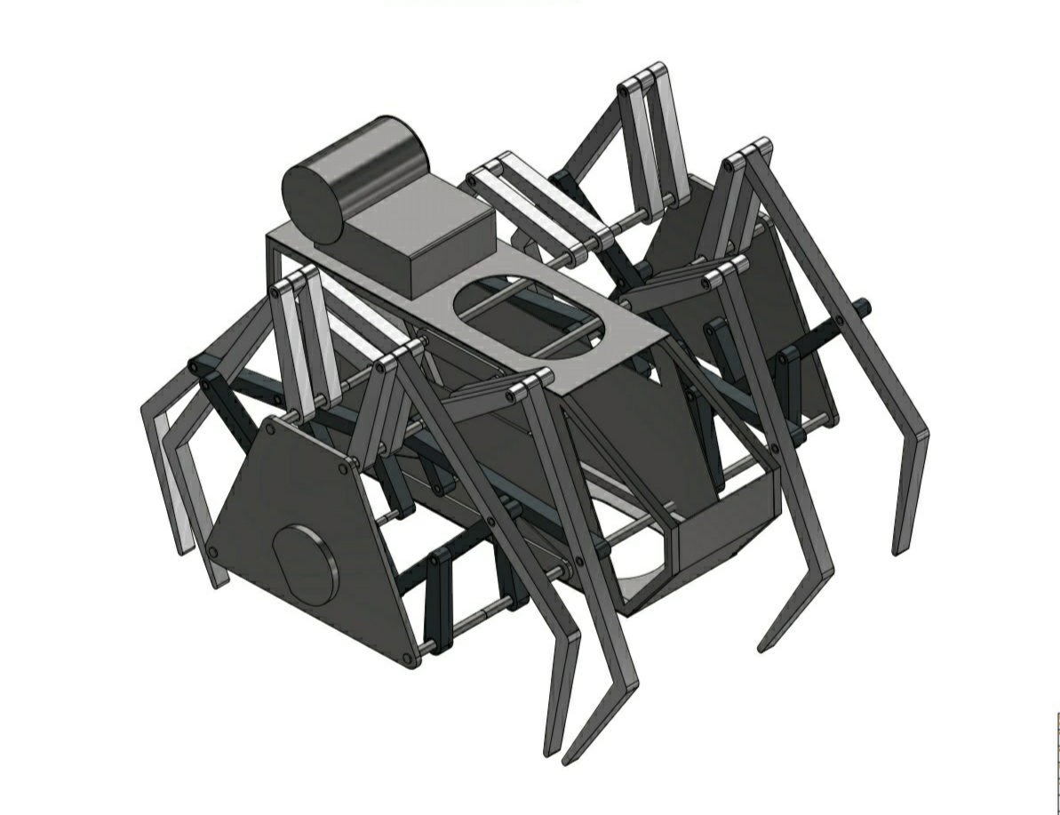**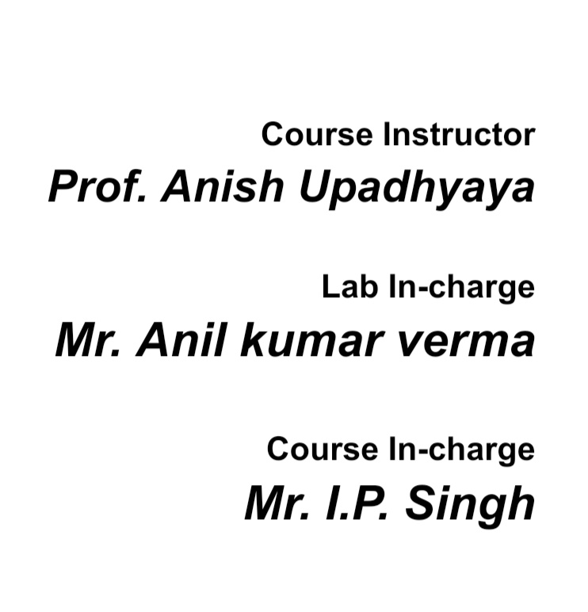Group members: -**

***Dibyojyoti Sinha (180244) Charandeep Kapoor (180204) Digamber Singh (180246)***

***Chandra Prakash Patel (180203) Deependra Chansoliya (180227) Bommisetti Gopinath (180201)***

# Contents

horizontal line

**Introduction**4

**Motivation6**

**Acknowledgement7**

**Work Distribution8**

**List of Materials9**

**Main Assembly11**

**Cabin Assembly12**

**Leg Pair Assembly13**

**Cabin Wall Assembly14**

**Cabin Frame15**

**Cabin Hold16**

**Cabin Side Panel17**

**Cabin Front Panel18**

**Cabin Back Panel19**

**Cabin Roof** **20**

**Crank Joint Pins** **21**

**Crank 22**

**Frame** **23**

**Leg** **24**

**Lower Rocker Arm** **25**

**Rocker Arm26**

**Upper Rocker Arm27**

**Rods28**

**Fly wheel** **29**

**Battery Box** **30**

**Leg Joint Pins** **31**

horizontal line

**INTRODUCTION**

horizontal line

The name of our project is *SPIDER CRAB*. It can also be observed by the diagram above why it is the name. The legs look like that of a Spider and that’s why the word spider is used. Now, why crab? The main body of a Spider is small as compared to legs, But our in the diagram it can be shown that the body is almost the size of the legs and looks like a crab. So, we decided to name it *SPIDER CRAB*.

What’s the Project?

In this project, we are making an insect-like object which is simply made by the compact arrangement of various small metallic parts which combine together to make a crawling body. The most interesting thing about this project is that even when we are not allowed to use any motor or some power source to drive the movement of the object, but we still have managed to make it movable. We have to fabricate various parts of the model though different methods like Casting, Cutting, Sheet metal forming and other fabrication methods used in the lab. Then finally we have to arrange the parts in a proper manner so that they can fit perfectly in their place and can be pivoted smoothly so that the object can be in motion. So, making something on our own that can be set in such motion gives satisfaction.

How does it work?

It is based upon a walking mechanism known as Klann linkage.

The proportions of each of the links in the mechanism are defined to optimize the linearity of the foot for one-half of the rotation of the crank. The remaining rotation of the crank allows the foot to be raised to a predetermined height before returning to the starting position and repeating the cycle. Two of these linkages coupled together at the crank and one-half cycle out of phase with each other will allow the frame of a vehicle to travel parallel to the ground.

# The Klann linkage provides many of the benefits of more advanced walking vehicles without some of their limitations. It can step over curbs, climb stairs, or travel into areas that are currently not accessible with wheels but does not require microprocessor control or multitudes of actuator mechanisms. It fits into the technological space between these walking devices and axle-driven wheels.

[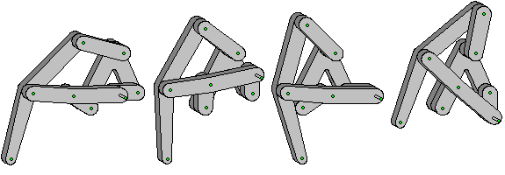](https://en.wikipedia.org/wiki/File:F1-positions.gif)

An Step-wise presentation of working of Klann linkage.

# horizontal lineMotivation

horizontal line

While looking for an effective idea for the project of TA201A, we were scrolling through many sources to get something that can be manufactured with the given facilities, and during this time only we came to know about such a project and we were excited about it.

This project attracted our attention when we saw its motion in a GIF. It looked simple and complex at the same time. Simple in the sense that it is just made of some thick metal rods and sheets of different thickness, and complex in a way that that fabrication and orientation of the different parts of the Spider crab have to be quite precise in order to make it move as we wanted.

This model fascinated in the very first look and we took no much time to decide that we have to make this thing. At first we were stuck in the confusion whether we will be able to make it or not as it involved moving parts and we did not have very much precision to make every part. But finally, we encountered this confusion with the help and advice of the lab in-charge.

we decided to apply various methods learned in the TA201A laboratory to convert into a real object. The real motivation behind doing this project was the excitement and curiosity to take such a job on hand and accomplish it with our hands.

 We were so much fascinated by that GIF and the compact design of the model that we wondered how satisfying it would be when we will physically manufacture that model with the very raw materials that we will use. After we started converting our idea into a project through AutoCAD, the motivation to make it went higher and we had all the plans ready to accomplish it.

horizontal line

# ACKNOWLEDGEMENT



As a team, we made all our efforts to make this project a successful one and we showed a good teamwork to accomplish it. But this would be difficult to do without any help from someone experienced. This project could land on real grounds because of the help, support and guidance of our TAs and the lab staff who really helped and cooperated in making this project successful.

We are deeply grateful to our tutors and the MSE laboratory in-charge, Mr. Anil Kumar Verma, who gave valuable and constructive suggestions and advice during the planning and development of this project. Without their guidance and technical and mental support, it would be not have been able to complete this rigorous task. They always made us feel that we can finish our tasks even when some parts were tough to manufacture and assemble.

We would like to express our great appreciation towards our course in-charge, Mr. I.P. Singh who guided us through every step from choosing our project to giving it a finishing touch. We would also like to express our heartiest thanks to all the other laboratory staffs   ( Mr. Anurag Prasad, Mr. Shilankar, Mr. Rakesh Kumar, Mr. Anil Kumar Verma, Mr. Mewa Lal, Mr. Gaurav Mishra, and Mr. Nripen Deka ) for their constant supervision and encouragement throughout the project which helped us a lot in completion of our tasks.

Special thanks to all other people who work hard in the MSE laboratory to make our learning to the manufacturing processes easy and who keep the lab conducting smoothly which helps us in completing our tasks easily and on time.

Overall, A big thanks to our Instructor In-charge, Prof. Anish Upadhyaya for providing us with the opportunity to learn various manufacturing processes and gave us a chance to test our knowledge and skill through a project which gave us a job satisfaction like never before.

# horizontal line

# Work Distribution

horizontal line

|  |  |  |  |  |  |  |
| --- | --- | --- | --- | --- | --- | --- |
| Members | Week 1 | Week 2 | Week 3 | Week 4 | Week 5 | Week 6 |
| ***Dibyojyoti Sinha*** | Leg,  Upper  Rocker Arm, | Crank,  Rocker Arm,  Lower Rocker Arm | Crank Joint Pins,  Crank Coupler Pins | Leg Sub  Assembly | Assembly | Assembly and finishing |
| ***Chandra Prakash Patel*** | Leg,  Upper  Rocker Arm | Crank,  Rocker Arm,  Lower Rocker Arm | Crank Joint Pin,  Crank Coupler Pin | Leg Sub  Assembly | Assembly | Assembly and finishing |
| ***Deependra Chansoliya*** | Cabin Hold,  Upper  Rocker Arm,  Frame | Crank,  Rocker Arm,  Lower Rocker Arm | Crank Coupler Pin Extended,  Short Joint Pin | Leg Sub  Assembly | Assembly | Assembly and finishing |
| ***Bommisetti Gopinath*** | Frame,  Cabin Hold | Cabin Front Panel,  Fly Wheel, | Long Joint Pin,  Rods | Cabin Sub Assembly | Assembly | Assembly and finishing |
| ***Digamber Singh*** | Cabin Roof,  Cabin Frame,  Cabin Side Panels, | Cabin Back Panel,  Battery Box | Upper Rocker Joint Pin,  Crank Coupler Pin Extended, | Cabin Sub Assembly | Assembly | Assembly and finishing |
| ***Charandeep Kapoor*** | Cabin Roof,  Cabin Frame,  Cabin Side Panels, | Battery Box,  Fly Wheel, | Short Joint Pins | Cabin Sub Assembly | Assembly | Assembly and finishing |

# List of Materials

horizontal line

|  |  |  |  |  |  |
| --- | --- | --- | --- | --- | --- |
| Part No.: | Name | Material Used | Number of parts | Dimension for one part | Process |
| 1 | Cabin Frame | Mild Steel Square Rod (6mm x 6mm) | 2 | Length:  810mm | Fabrication (cutting and bending) |
| 2 | Cabin Hold | Mild Steel Sheet  (2mm and 1mm) | 2 | 2mm sheet: 250mm x 50mm  1mm sheet:  200mm x 50mm | Sheet Metal Forming (cutting) |
| 3 | Cabin Side Panel | Mild Steel Sheet (1mm) | 2 | 300mm x 150mm | Sheet Metal Forming (cutting) |
| 4 | Cabin Front Panel | Mild Steel Sheet  (1mm) | 1 | 100mm x 100mm | Sheet Metal Forming (cutting) |
| 5 | Cabin Back Panel | Mild Steel Sheet (1mm) | 1 | 150mm x 200mm | Sheet Metal Forming (cutting) |
| 6 | Cabin Roof | Mild Steel Sheet | 2 | 250mm x 100mm | Sheet Metal Forming (cutting) |
| 7.1 | Crank Joint Pin | Mild Steel Rod (ø4mm) | 2 | Length: 20mm | Fabrication (cutting) |
| 7.2 | Crank Coupler Pin | Mild Steel Rod (ø4mm) | 2 | Length: 40mm | Fabrication  (cutting) |
| 7.3 | Crank Coupler Pin Extended | Mild Steel Rod (ø4mm) | 1 | Length: 140mm | Fabrication  (cutting) |
| 8 | Crank | Mild Steel Square Rod (6mm x 6mm),  Mild Steel Sheet (2mm) | 8 | Sq. Rod:  Length: 30mm  Sheet:  60mm x 30mm | Sheet Metal Forming, Fabrication and welding |
| 9 | Frame | Mild Steel Sheet (two 2mm sheets) | 2 | 300 x 200 cm | Sheet Metal Forming and soldering |
| 10 | Leg | Aluminum | 8 | 80 grams | Casting |
| 11 | Lower Rocket Arm | Mild Steel Square Rod (6mm x 6mm),  Mild Steel Sheet (2mm) | 8 | Sq. Rod:  Length: 40mm  Sheet:  100mm x 50mm | Sheet Metal Forming, Fabrication and welding |
| 12 | Rocker Arm | Mild Steel Square Rod (6mm x 6mm),  Mild Steel Sheet (2mm) | 8 | Sq. Rod:  Length: 140mm  Sheet:  200mm x 30mm | Sheet Metal Forming, Fabrication and welding |
| 13 | Upper Rocker Arm | Mild Steel Square Rod (6mm x 6mm),  Mild Steel Sheet (2mm) | 16 | Sq. Rod:  Length: 60mm  Sheet:  100mm x 50mm | Sheet Metal Forming, Fabrication and welding |
| 14 | Rods | Mild Steel Rod (ø 4mm and ø6mm) | 1(ø4mm)  1(ø6mm) | Length; 40cmm | Fabrication (cutting) |
| 15 | Fly Wheel | Cast Iron | 1 | 80grams | Casting and Welding |
| 16 | Battery Box | Mild Steel Sheet (1mm) | 1 | 200mm x 180mm | Sheet Metal Forming and spot welding,  soldering |
| 17.1 | Long Joint Pin | Mild Steel Rod (ø 4mm) | 4 | Length: 50mm | Fabrication  (cutting) |
| 17.2 | Upper Rocker Joint Pin  (~Joint Pin) | Mild Steel Rod(ø 4mm) | 8 | Length: 40mm | Fabrication  (cutting) |
| 17.3 | Short Joint Pin | Mild steel Rod (ø 4mm) | 16 | Length: 30mm | Fabrication  (cutting) |

horizontal line